Design Doc Template

*Author(s): xyz*

*Date: 22/05/2019*

Revision: 0

Document Status: Draft [Draft, Completed, Submitted, Reviewed, Final]

Project Status: In-Progress [In Review, Approved, In-Progress, Completed]

Revision History

|  |  |  |  |
| --- | --- | --- | --- |
| Date | Revision | Description | Author |
| 22/05/2019 | 0 | Initial draft of the design doc template | xyz |
|  |  |  |  |
|  |  |  |  |
|  |  |  |  |
|  |  |  |  |
|  |  |  |  |
|  |  |  |  |
|  |  |  |  |
|  |  |  |  |
|  |  |  |  |

**Table of Contents**

TOC \o "1-3" \h \z \u Introduction

Summary

Background

Definitions, Acronyms, and Abbreviations

Design Overview

Requirements

Documentation

Minimum Viable Product

Stretch goals

Future work

Architectural Diagrams

System Diagrams

Application Programming Interface

Recommendations

User Interface

Data Models and Storage

Service Operability

Key Performance Indicators

Service Level Objectives

Project Overview

Communication and Tracking

Risks

Milestones

Project Phases

Cost

Frequently Asked Question

References

Addendum

# 

# Introduction

## Summary

According to WHO , 1 in every 4 is suffering from Anaemia and 1 in every 10 is suffering from Diabetes, and this ratio might become 1:10 by 2025. To avoid unexpected and severe health hazards, it is important to monitor glucose and haemoglobin levels daily. The existing solutions to monitor these levels involve pricking fingers, taking blood out of the body by piercing the skin which is painful. So developing a product that monitors glucose and haemoglobin levels of body in non-invasive way will be quite advantageous and useful.

## Background

Existing methods to measure/monitor glucose levels in body, haemoglobin concentration levels in blood are painful and difficult to take without help of any doctor or nurse. We are trying to develop, non-invasive Gluco-Haemo meter, a non-invasive glucose levels and haemoglobin levels measuring device. It is actually difficult to measure these levels without blood. To measure in non-invasive method, it requires lot of knowledge and idea on blood, glucose levels, haemoglobin, factors affecting the concentration of haemoglobin, and also the knowledge of various sensors, microprocessors and microcontrollers.

Our device will stand unique from the crowd of existing solutions to measure the glucose and haemoglobin levels, which give results in 15-20 minutes, as our is non-invasive, easy to handle, portable, gives result in few seconds.

## Definitions, Acronyms, and Abbreviations

**Photoplethysmography (PPG)** - Photoplethysmogram is an optically obtained plethysmogram(plethysmograph is an instrument for measuring changes in volume within an organ) that can be used to detect blood volume changes in the microvascular bed of tissue.

**Pulse oximetry** - is an non invasive method for monitoring a person’s oxygen saturation.

**Beer Lambert’s law** - It states that the quantity of light absorbed by a substance dissolved in a fully transmitting solvent is directly proportional to the concentration of the substance and the path length of the light through the solution.

# Design Overview

## Requirements

The requirements for us to build the product are the suitable electronic components which could be able to monitor the blood glucose and haemoglobin levels.

Customer Requirements : The product should be economically feasible , portable maybe fit in pocket and accurate as same as invasive devices which are currently existing in the market.

### Documentation

## Minimum Viable Product

Our device consists of an IR and red light and a photodiode on which the light is incident and based on the optical characteristics of haemoglobin and blood we will be predicting the blood glucose and haemoglobin levels using Matlab and all these components are interfaced with the Arduino Nano.

The whole product is built in such a way that it is wearable and portable so that the the user can wear it whenever he/she wants to monitor their glucose and haemoglobin levels.

## Stretch goals

## Future work

# Architectural Diagrams

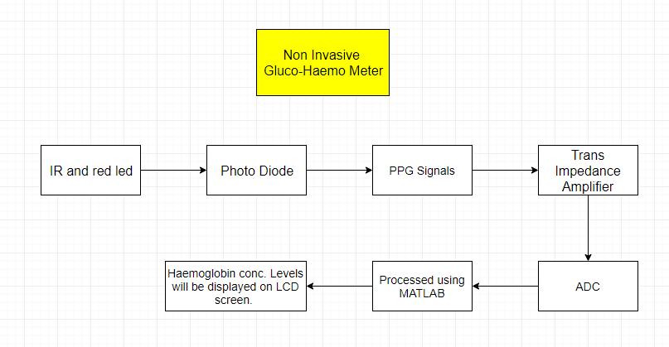

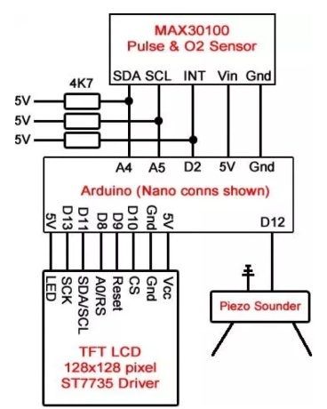

Application Programming Interface

## Recommendations

# User Interface

# Project Overview

## Communication and Tracking

## Risks

Our project uses hardware components,so failure of working of these components would give inaccurate results and this is our major risk.

## Milestones

An attempt to make our device compatible and feasible within six weeks.

## Project Phases

At first we had an idea of developing a non invasive device which can only detect glucose levels but after thorough research we came to know that even Anaemia patients are increasing day by day so we came to a conclusion that it is important to monitor both blood glucose and haemoglobin levels respectively and we are in a process of modification of our device to detect both glucose and haemoglobin levels.

## Cost

A week ago we started our work by studying several journals and understanding the link between the medical and engineering to convert our idea into a product ,collecting the data for selection of components which are more efficient to our product and continued to work with the prototype simultaneously we have talked to doctors and our target customers and discussed with them about our idea and took their suggestions and added modifications to our prototype but to calibrate the values accurately it will take more four days.After this,conversion of prototype into a product will take a week time.

**Materials used**

**Fabrication Work**

# Frequently Asked Question

# References

<https://link.springer.com/chapter/10.1007/978-3-540-89208-3_414>

<https://www.researchgate.net/publication/284672889_Low_Cost_Calibration_Free_Pulse_Oximeter>

<http://iaetsdjaras.org/gallery/54-april-697.pdf>

<https://www.ijareeie.com/upload/2018/april/52_ESTIMATION.pdf>

<https://pdfs.semanticscholar.org/e1f2/5cacf51d1cc27ea37978c76d8e5a9338d13d.pdf>